1. **Chapter 1 Analysis**

**Use Case Diagrams**

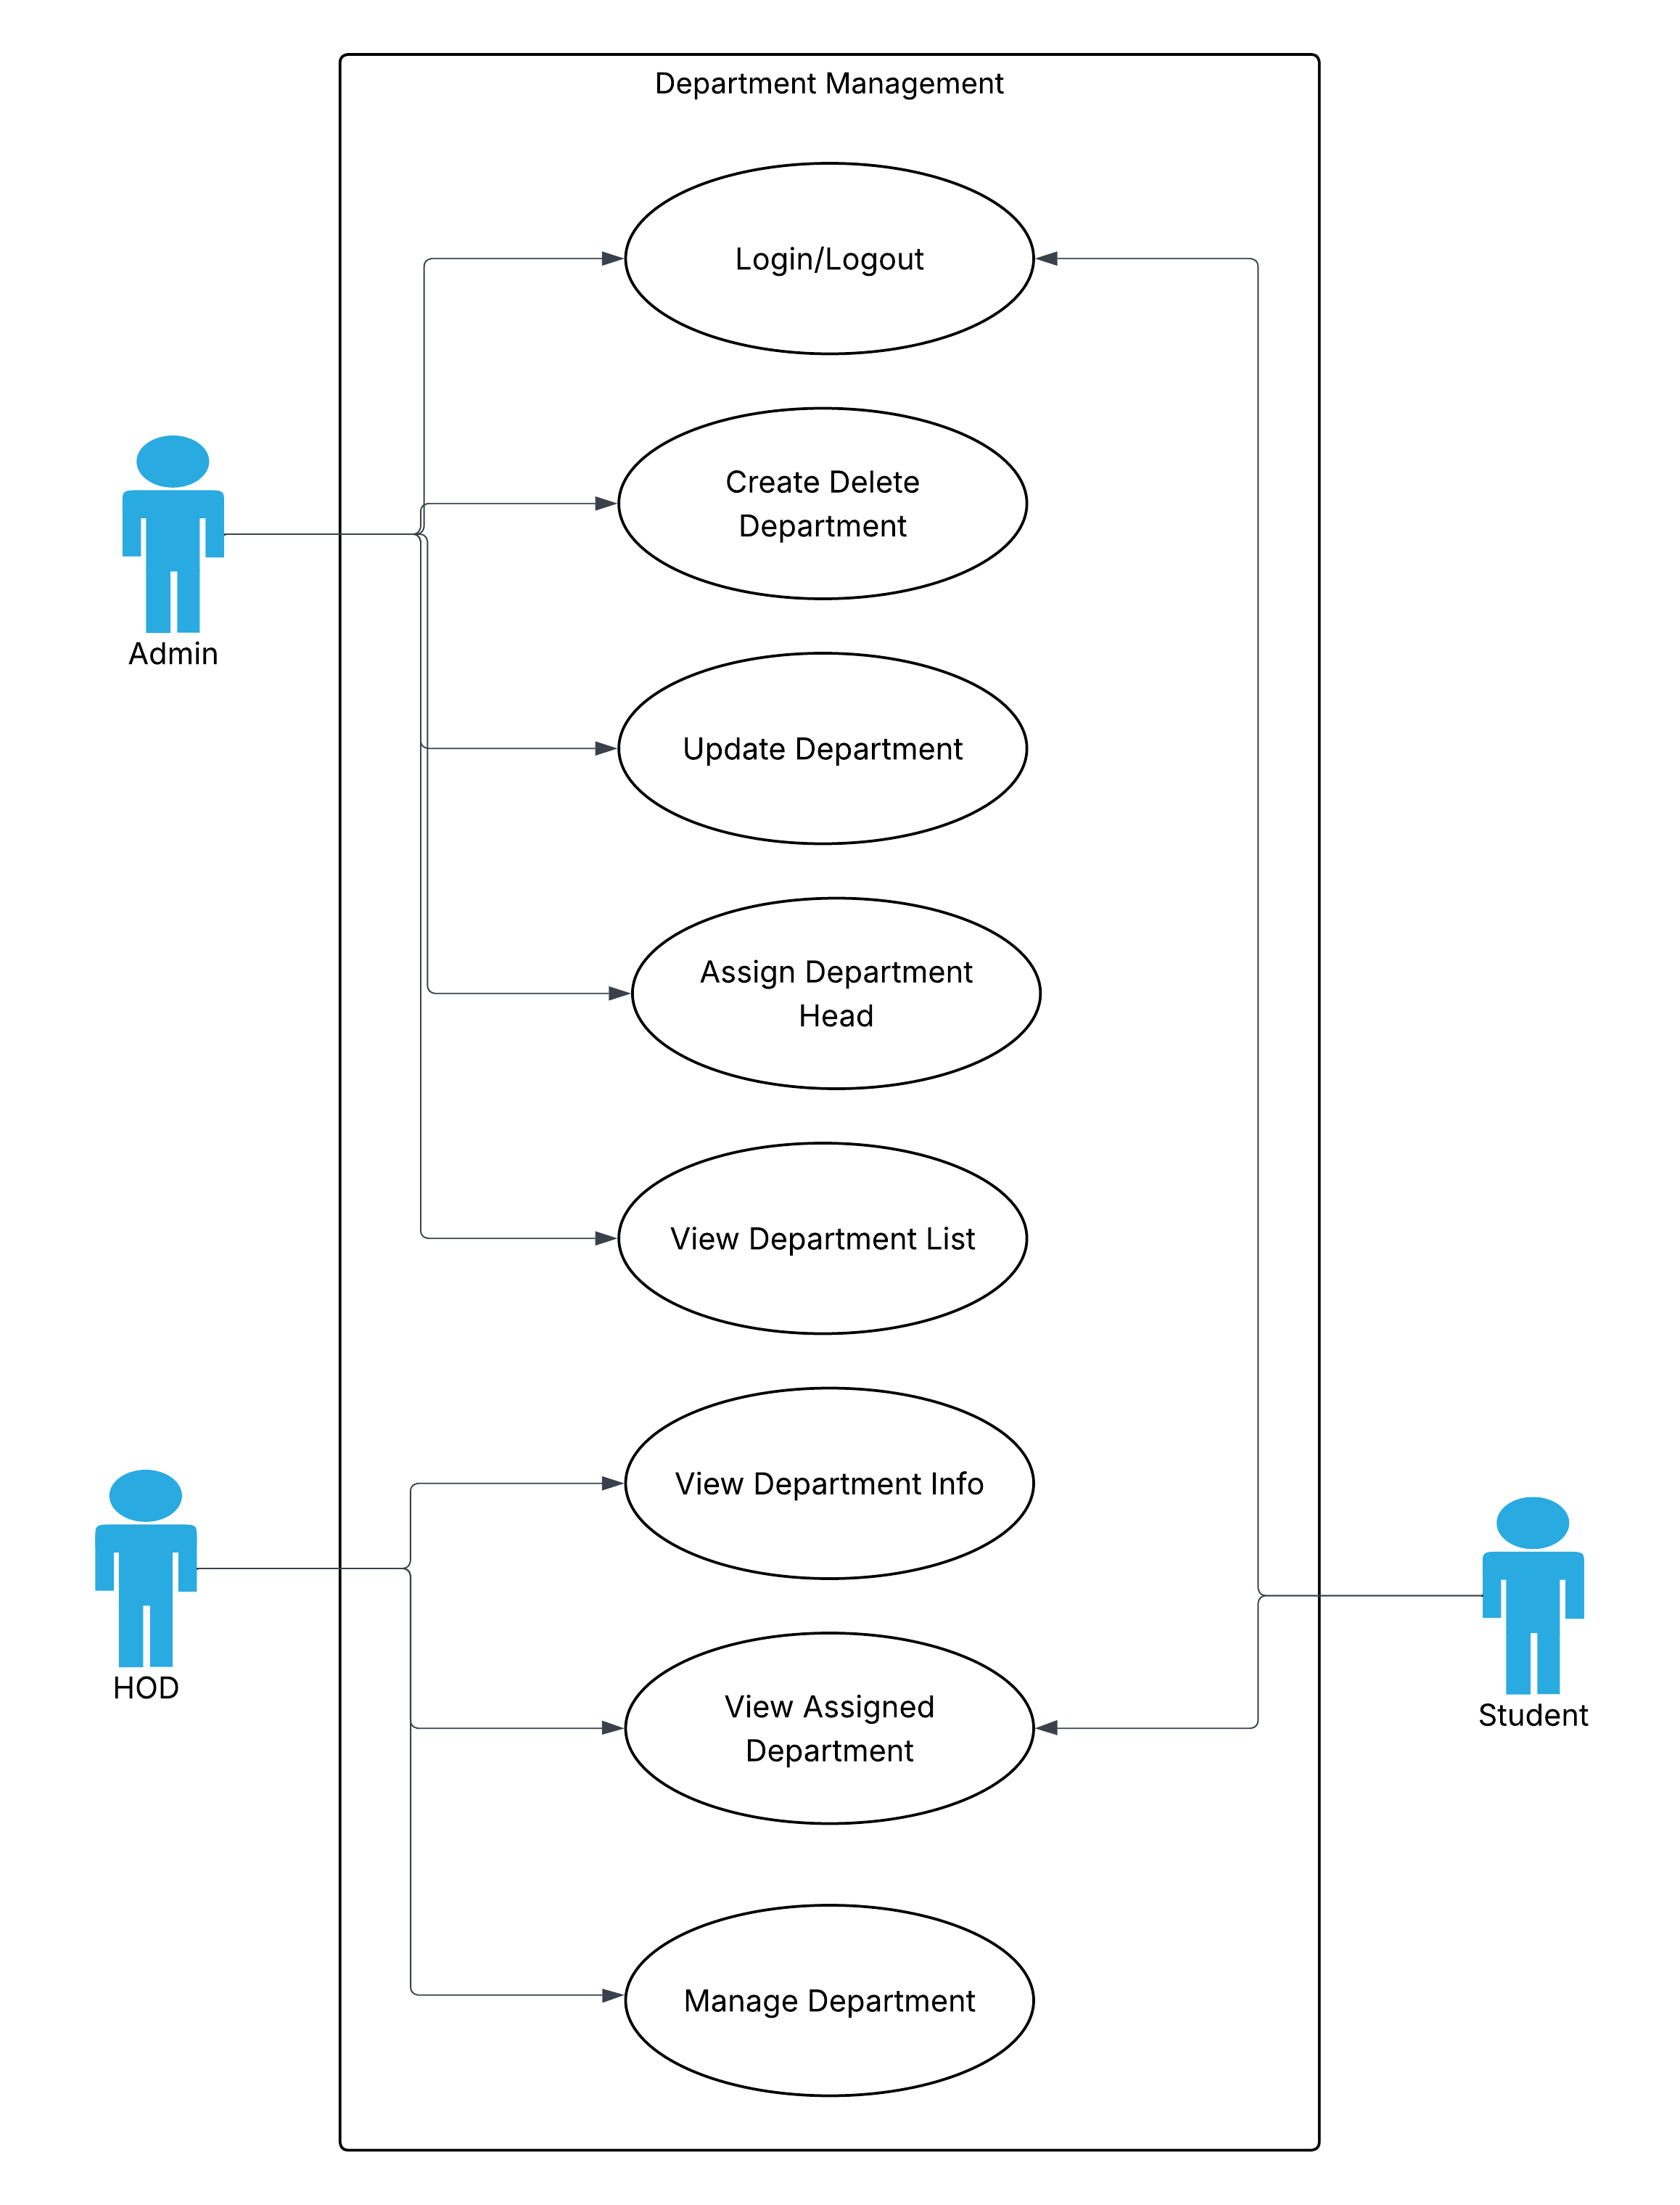

1. **Fully Dressed Use Cases**

**Name: M. Usman Waqar Khan**

| **Use Case Element** | **Details** |
| --- | --- |
| **Use Case Name** | Assign Department Head |
| **Primary Actor** | Admin (System Administrator) |
| **Goal in Context** | To assign a specific user (e.g., a teacher) as the Head of a selected department |
| **Scope** | User and Role Management Module |
| **Level** | User goal |
| **Stakeholders and Interests** | - **Admin** wants each department to have a responsible head- **System** ensures role control and department integrity- **New Head** should be properly notified and assigned necessary permissions |
| **Preconditions** | - Admin is authenticated and authorized- Departments and eligible users exist in the system |
| **Postconditions (Success)** | - The selected user is marked as Head for the chosen department and can access Head privileges |
| **Postconditions (Failure)** | - The system shows an error; no changes are made to department roles or user status |
| **Main Success Scenario** | 1. Admin selects "Assign Department Head"  2. Admin chooses department  3. System shows current head (if any) and eligible users  4. Admin selects a user  5. Admin confirms  6. System saves assignment and shows success |
| **Extensions (Alternate Flows)** | - **2a.** No departments → System shows: "No departments available"-  **3a.** No eligible users → System shows: "No eligible users for this department"-  **4a.** Admin cancels → System exits-  **5a.** Error saving → System shows error message |
| **Special Requirements** | - Only one Head per department allowed- Assigned user must be a teacher or staff- System logs the assignment in audit trail |
| **Frequency of Use** | Occasionally — only when assigning or changing department heads |
| **Open Issues** | - Should previous Head be notified or auto-demoted? - Should the new Head receive extra privileges instantly? |

1. **Class Diagram**

**Name: M. Usman Waqar Khan**

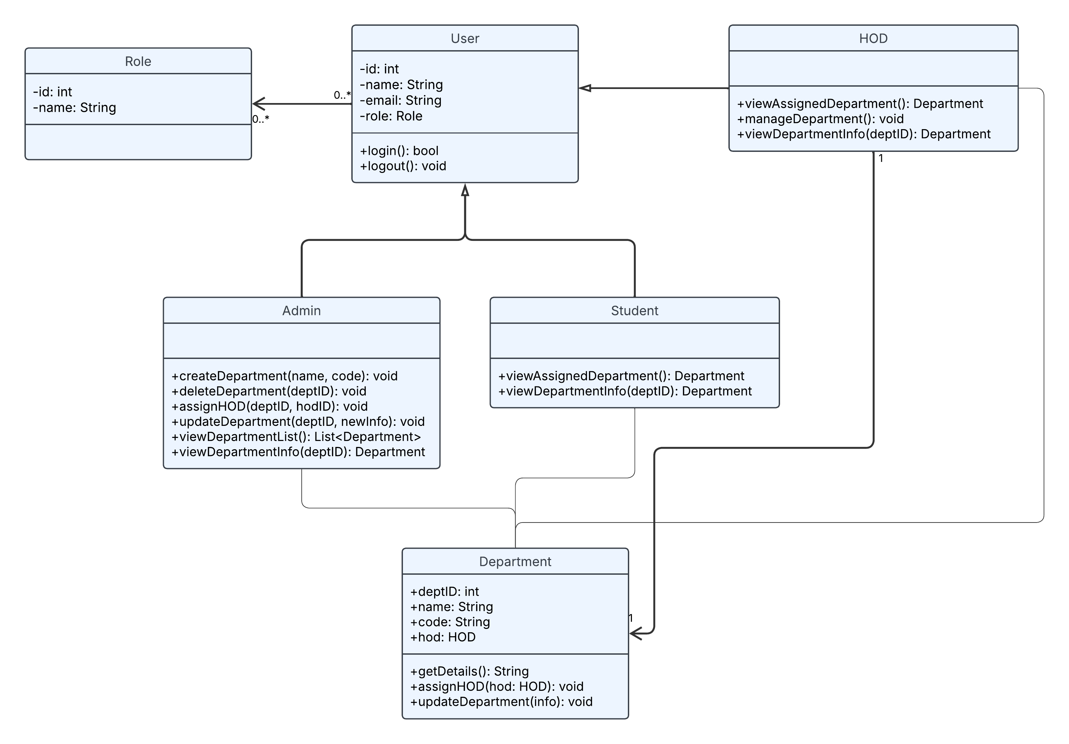

**System Sequence Diagram**

**Name: M. Usman Waqar Khan**

